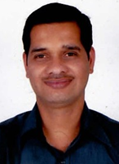
SHREENIVASA K M
Contact: 07200018488 E-Mail: shreenivasa.km@gmail.com
LinkedIn Profile: https://www.linkedin.com/profile/view?id=16301651&trk=nav_responsive_tab_profile

SENIOR LEVEL PROFESSIONAL

Dedicated & knowledgeable professional aiming for senior level assignments in System Architecture / Software Development & Designing / Application Support with an organization of high repute

- Offering rich business acumen & record of flawless service & achievements across a diverse range of functions

VALUE PROPOSITION:

- Merit of designing configurable firmware to adopt different:
- Customer’s specifications which reduced time taken to market the product
- Hardware to reduce product BOM (Bill of Material) cost
- Instrumental in translating organizational values, vision and aligned attitude of team to achieve excellence.
- Extending effort and proposing different ideas to promote product which helped in product marketing.
- Skilled in identifying unknown/random challenges and helped to improve the product.
- Have effective communications with team and ensuring on time delivery of packages to stakeholders.

PROFILE SUMMARY

- A competent professional with over 12 years of experience in:

Firmware Development System Architecture Device Driver Development
Smart Metering Solution using GSM Liaison & Coordination Team Management
Software Configuration Management Release Management Integration Test
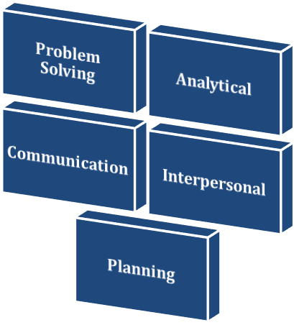
- Expertise in developing HLD to meet existing & future customer’s specification which helped in fast configurability, development & faster Time to market.
- Adroit in managing projects and new systems implementations for streamlining operations within time & cost parameters as per organizations’ quality standards
- Hands-on experience in mapping requirements, customizing design solutions & troubleshooting for complex software & application problems
- Functional expertise in all aspects of SDLC involving requirement analysis, coding, design, development, documentation, implementation, etc.
- Demonstrated abilities in handling activities related to integration testing of Driver, Firmware, Operating System, Testing Application, Verification and Reporting Defect
- Hands-on experience in Release Management and helped project with on time delivery
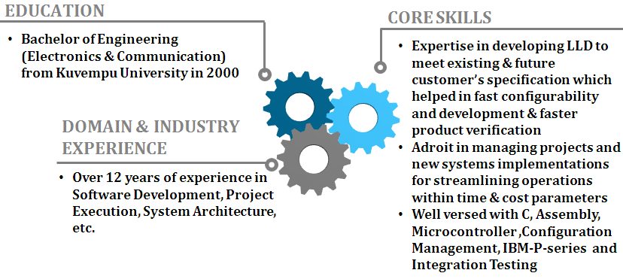
- An effective communicator with good leadership, time management, planning and problem solving skills

ORGANISATIONAL EXPERIENCE

Since Jul’13 Simco Engineering Ltd., Tamil Nadu as Firmware Lead
(Spearheading a team of 4 people)

Jun’10-Jun’13 Deltazia SCM Solutions-Integrator, Bangalore as SCM Consultant


May’05-May’10 HCL Technologies, Chennai as Member of Technical Staff

May04-Apr-05 ICSA (I) Ltd, Hyderabad as Sr.Engineer

Feb02-Mar-04 Convoy Soft Sol, Bangalore, as Engineer

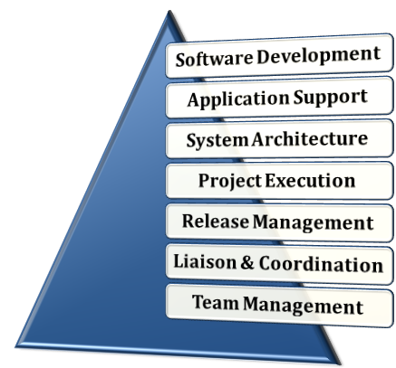
Key Result Areas:
- Mapping clients’ requirements & providing them best solutions involving evaluation & definition of scope of project and finalisation of project requirements
- Managing entire application development operations involving requirement analysing, developing HLD & LLD
- Monitoring project progress for ensuring quality & timeliness of deliverables and reporting on projects progress
- Handling various technical aspects like supporting application/product design & development, testing, integration, troubleshooting and debugging of the software application
- Performing functionality & integration testing of modules and releasing packages to require stake holders.
- Managing the implementation phase by formulating plans, planning resources, and managing issues arising due to scope creep or other matters related to technicality & personnel

PREVIOUS EXPERIENCE

May’04-May’05 ICSA (I) Ltd., Hyderabad as Sr. Engineer

Feb’02-Apr’04 Convoy Soft Soln, Bangalore as Engineer

TRAINING

- Attended Web Program regarding Project & Time Management

IT SKILLS

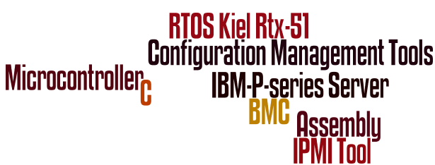
Well versed with:
- C & Assembly
- Microcontroller (Teridian Energy Meter IC & 8051)
- Peripheral Interface & Driver development
- RTOS – Kiel Rtx-51
- Configuration Management Tools (Clear Case, Clear Quest & Hudson)
- Designed & implemented LRU Replacement Test Protocol
- BMC, IBM-P-series Server, IPMI Tool

EDUCATION

- Bachelor of Engineering (Electronics & Communication) from AIT, Chikmagalore, Kuvempu University in 2000

PERSONAL DETAILS

Date of Birth: 17th March, 1979
Address: #6/21, Tagore Street, LIC Colony, KK Nagar, Trichy - 650021
Languages Known: English & Hindi
Location Preference: South India

Please refer Annexure for Projects
ANNEXURE

Project Handled at Simco Engineering Ltd.
Title: Energy Meter: Common Platform Firmware
Environment: Teridain Energy metering IC
Hardware: In-house developed HW for energy meter
Tools: Kiel Development Tools
Description: A single phase CT operated energy meter was designed for LV application with different ranges. These meters were designed for 2 measuring & 4-quadrent system, developed on Terridain Energy metering IC with accuracy class 1 which meets IEC1377 specifications. This meter designed for configurable time of use tariffs, has anti tamper & immune to tamper conditions.
Role:
- Accountable for architecting common platform firmware
- Developed LLD to meet existing & future customer’s specification which helped in fast configurability and development, faster product verification & validation

Project Handled at Deltazia SCM Solutions

Title: Digital TV Systems
Environment: Linux
Hardware: Freeman
Tool: MKS
Description: Digital TV System-on-Chip offered first-of-its-kind integrated 3D graphics accelerator, enabling next-generation internet TV services, exciting user interfaces & casual gaming. These products powered high-performance TVs that demand exceptional video, audio & user-interface capabilities, strong security dedicated for advanced middleware/internet TV applications. It was compatible with worldwide digital terrestrial television (DTT) standards. It also introduced a new high-quality Faroudja video-enhancement IC that dramatically reduced TV power consumption and boosts video quality for LED TVs while offering best-in-class experience for 2D/3DTV.
Role:
- Handled activities related to:
- Black box testing, defects reporting and maintenance of software quality
- Triggering release build, package creation and deployment
- Analyzed defects and assisted developer by debugging issues
- Accountable for software releases and customer bug fixing

Projects Handled at HCL Technologies

Title: System Driver Integration
Environment: Linux, VIOS & AIX
Hardware: P-series IBM Servers
Tools: IPMI-Tool and IBM Director
Description: It involved functionality verification & validation of drivers & firmware on multiple platforms of IBM server hardware. It also helped in enhancing system performance and customer satisfaction by providing strong working platform for testing and development team.
Role:
- Handled activities related to:
- Integration testing of firmware with OS & firmware and reported defects
- Preparation of release documents and published the same to all stakeholders
- Configuration & testing of IBM-director for all platforms
- Accountable for testing new release of operating system
- Carried out testing of new release VIOS on different platforms, NIM, DVD, etc.

Title: Flexible Service Processor
Environment: Linux
Hardware: P-series IBM Servers
Languages: C

Description: The baseboard management controller provided environmental monitoring for the server. If environmental conditions exceed thresholds or if system components fail, the baseboard management controller will light LEDs to help you diagnose the problem, and will also record the error in the BMC System Event/Error log.
Role:
- Identified requirements and prepared & implemented LLD
- Accountable for fixing defects and documenting process to versioning source code
- Provided assistance to team members for carrying out versioning

Title: LRU Replacement Test
Environment: Linux
Languages: C
Tools: DOORS
Description: This embedded system was designed for health reporting of flight. This module received health information of flight from OHMF and it reported periodically to health management software component. This system monitored inhibited conditions & if these conditions were enabled, system prevented all other tests and reporting inhibited conditions to health management software component. The system performed initiated tests on LRU to check the health of LRUs and enabled maintenance engineer to replace the LRUs.
Role:
- Assisted team members in analysing root cause of defects and executed defect preventive methods
- Developed & implemented HLD & LLD
- Attended review meetings of LLD & source code and rectified errors

Project Handled at ICSA (I) Ltd.

Title: Intelligent Automatic Meter Reader
Environment: Microcontroller-8051
Languages: C and AT Commands
Hardware: Energy Meters, IR Sensors & Modem
Description: Embedded System was developed for remote data collection which incorporated solution to improve power management & immediate billing generation efficiency. System detected tamper automatically & communicates alert signal to control room as well as field official's cell phone with tamper details. System had facility to less maintenance delay as system health could be checked remotely by the field officials.
Role:
- Looked after functional & integration testing of modem & metering devices
- Accountable for undertaking activities like field testing, installation & commissioning at client place
- Prepared documents for bidding process

Project Handled at Convoy Soft Soln

Title: IMPASSE
Environment: Microcontroller-8051
Languages: C
Hardware: Temperature, Pressure Sensors & Dialers
Description: Embedded System was developed for measurement & replacement of analog meters which had capability to display industrial electrical parameters like voltage, current, active power, frequency, power factor and kilo watt per hour (KWH). Once system detected any hazardous conditions, system delivered alert message by automatically dials to field officials & system make sure that alert message delivered to destination in case of unavailability of field officials by automatically dialling to other number which were pre-programmed. It could be altered by user using user friendly menu.
Role:
- Developed multiplexed architecture of analog data acquisition and firmware for the same
- Accountable for design & implementation of firmware
- Designed & calibrated analog circuits

